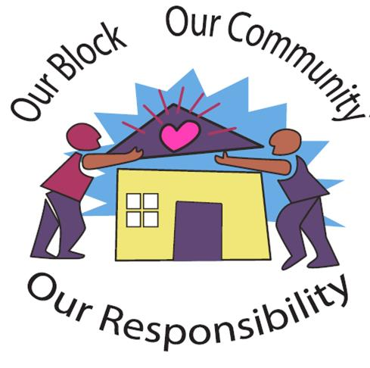

**Want to know the best crime prevention tool ever invented?**

**A good neighbor!**

Statistics show that neighbors working together with law enforcement is one of the best crime-fighting teams around.

**Neighborhood Watch**

A watch group is **an association of neighbors who look out for each other's families and property,** alert the police to any suspicious activities or crime in progress, and work together to make their community a safer and better place to live.

**It does not** involve carrying weapons or intruding on privacy or property rights

**It is not** a vigilante force working outside the normal procedures of the local police department or sheriff's office.

**It is not** a 100% guarantee that crime will not occur in your neighborhood.

**It is not** a program designed for participants to undertake personal risks to deter crime.

**Neighborhood Watch works because it reduces opportunities for crime to occur**

**It involves:**

**Working for a better and safer neighborhood through protecting and honoring the rights of others.**

A crime prevention program which **teaches Participants how to make their homes more secure, to properly identify their property, and how to “LOOKOUT FOR EACH OTHER!"**

**Neighbors getting to know each other and working together in a program of mutual assistance;**

**Residents trained to recognize and report suspicious activities in their neighborhoods**

**By cooperating with each other** and law enforcement, people can help fight crime in their communities the most effective way - **before it begins.**